MS189 | WALKING THROUGH TIME | CHAPTER 10

Walking through time

Chapter 10
Edwin Bidwell Wilson
Born: 25 April 1879 in Hartford, Connecticut, USA
Died: 28 December 1964 in Brookline, Massachusetts, USA
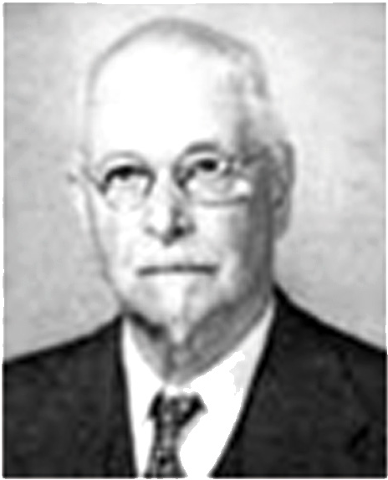
Edwin Wilson’s father, Edwin Horace Wilson, was a high school teacher. His mother was Jane Amelia Bidwell. Wilson studied at Harvard University, graduating with an A.B. in 1899. He then decided to work for a Doctor of Philosophy at Yale and there he was a student at Gibbs. Wilson graduated from Yale with a Ph.D. in 1901 and, in the same year, a textbook he wrote about vector analysis was published. Vector analysis (1901) was based on Gibbs’ lectures and [1]: -

This beautiful work, published when Wilson was only twenty-two years old, had a profound and lasting influence on the notation for and the use of vector analysis.
Wilson was appointed an instructor at Yale in 1900 and, after being awarded his doctorate, Wilson went to Paris where he studied at the École Polytechnique, the Sorbonne and the Collège de France during 1902-1903. On returning to the United States he continued to teach mathematics as an instructor at Yale. He became interested in the foundations of geometry, particularly in projective and differential geometry and he published a paper which criticised Hilbert's approach to geometry.

In 1906, Wilson was appointed as an assistant professor at Yale, then in 1907 he was appointed associate professor at the Massachusetts Institute of Technology. In 1911, he was promoted to full professor. Wilson had been inspired by Gibbs to work on mathematical physics and he began to write papers on mechanics and the theory of relativity. In 1912 Wilson published the first American advanced calculus text [1]:-

… a comprehensive text on advanced calculus that was the first really modern book of its kind in the United States.

Holding the position of professor of physics at the Massachusetts Institute of Technology, has prompted his appointment as Head of the Physics Department in 1917. World War I has seen another step in the interests of Wilson's research. He has carried out war work involving aerodynamics and this led him to study the effects of wind on the plane. In 1920, he published the third major Aeronautics text and he had collected a group of students to research on this topic. Wilson has served in quite a few different areas and his aeronautics works did not become the main topic of his career. Shortly after the publication of the Aeronautics text, his interest changed again, this time towards probability and statistics.

He did not study statistics for its own, but he was interested in the use of statistics for astronomy and for biology. He was the first to study the confidence interval, then rediscovered by Neyman. In 1922, Wilson left the Massachusetts Institute of Technology to be an important professor of Statistics at Harvard's Public Health School. He continued to hold this position until he retired in 1945. After retirement, Wilson spent a year in Glasgow, Scotland when Stevenson lectured on citizenship. From 1948, he was a consultant to the Naval Research Office in Boston.

Gridgeman and Mac Lane in [1] sum up Edwin Wilson’s contributions as follows:-

Wilson exhibited a critical mind, quick to expose weaknesses and errors. Each of his books was an effective and timely exposition of a major subject, and his best papers made lasting impressions. He contributed in many disciplines other than his specialities, including epidemiology, socially, and economics. His greatest originality may have been reached in his papers on statistics - which, interestingly, was a subject he did not explore deeply until middle age.

Wilson received many honours. He was a member of the National Academy of Sciences and he served as vice-president during the years 1949-1953. He was elected a Fellow of the Royal Statistical Society of London, and he was a member of the American Statistical Association, serving as president in 1929. He was also a member of the American Academy of Arts and Sciences, again serving as president during 1927-1931. Finally his membership of the American Philosophical Society was recorded.

Article by: J J O’Connor and E F Robertson Source: http://www-groups.dcs.st-and.ac.uk

