MS145 | WALKING THROUGH TIME | CHAPTER 8
Walking through time
Chapter 8
The concept of a proper function is an important concept in the mathematical world. It is the dominant point, line and theory from Ancient Greece to the Modern Age. Understanding its function and history is the basis of mathematical analysis, the theory that has become the centre of mathematical development ever since. In general, some mathematicians can make predictions with the modern concept of function formulation.
Oresme (1323-1382), is one of the developers of the geometric theory of shapes representing different levels of intensity and extension. The emergence of the idea of function as an individual mathematical field can be uncovered from the beginning of calculus.
Descartes (1596-1650) clearly states that the equations in two variables, geometrically represented by a curve, show dependence between the number of variables.
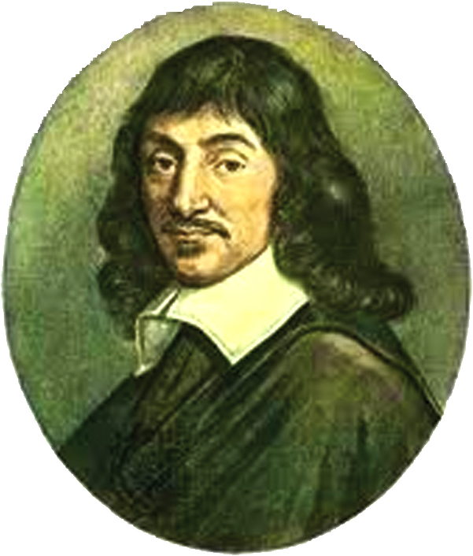
Newton (1642-1727) was also one of the first mathematicians who demonstrated how functions could be developed in unlimited power series, allowing for unlimited process intervention. He uses the term "fluent" to denote independent variables, "quantity relationships" to indicate dependent variables, and "genita" to refer to the sum derived from others using four basic arithmetic operations.
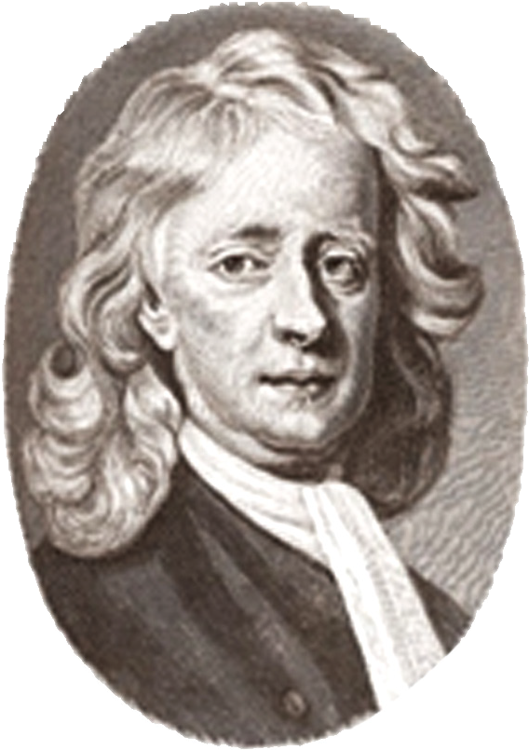
Leibniz (1646-1716) first used the term "function" in 1673. He took the function to point out, in very general terms, the dependence of geometric numbers such as sub-tangents and sub-normal on the shape of the curve. He also introduced the terms "constant", "variable", and "parameter".
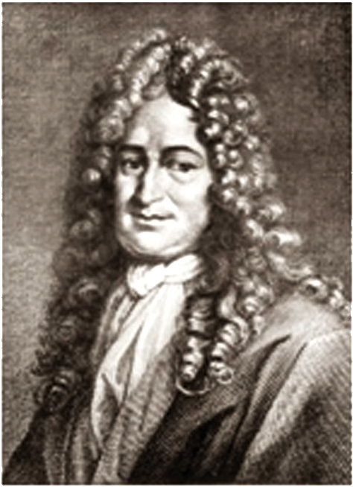

With the development of the curve with the algebraic method, a term for representing numbers that are dependent on one variable by means of analytic expression is increasingly needed. Finally, the "function" is adopted for that purpose in a correspondence exchanged by Leibniz and Jean Bernoulli (1667- 1748) between 1694 and 1698. Two years later, Bernoulli published an article that would have a wide spread of definitions about the function of variables as the sum organised in several ways from that of variables and constants.

