Walking Through Time

Abu Ja’far Muhammad ibn Musa Al-Khwarizmi was born around c. 780 in possibly Baghdad (now in Iraq) and died approximately in c. 850.

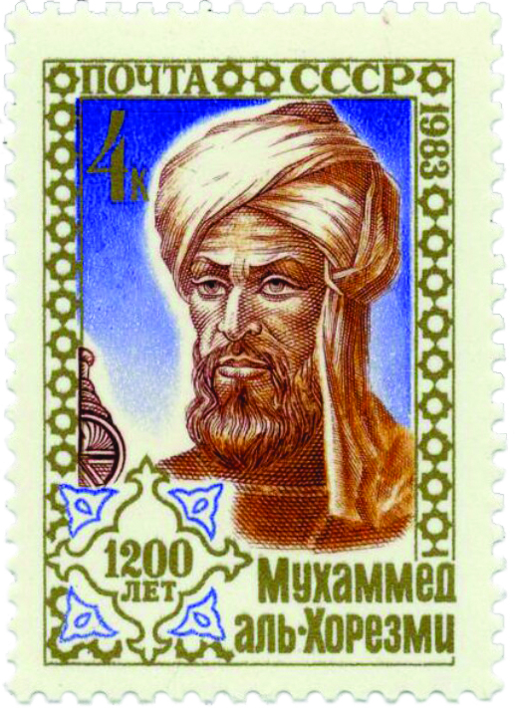
Al-Khwarizmi continued his studies in algebra at Hisab al-jabr w’al-muqabala where he also studied on how the arithmetic law was advanced to arithmetic algebra. For example he shows how to do such an expansion:

(a + bx)(c + dx)

Although we have to emphasize that al-Khwarizmi only uses words to describe his expressions, and no symbols were used. Rashed [9] sees the remarkable depth and renewal in this calculation by al-Khwarizmi which is clear to us, when examined from a modern perspective. He wrote [9]: -

The concept of Al-Khwarizmi algebra can now be given a consideration with higher accuracy: it is related to the theory of linear and quadratic equations with an unknown variable, and relative binomial arithmetic and trinomial. ... The solution should be general and calculated at the same time and in mathematical sentences it is based on geometry. ... Degree divider, as well as unspecified number of terms, is explained immediately. From its actual appearance, algebra can be seen as the theory of equations solved through radicals, and the algebraic calculations on related expressions ...

In [23] Gandz stated the following opinion on al-Khwarizmi algebra: -

Al-Khwarizmi Algebra is considered the basis of knowledge. In other words, al-Khwarizmi is better entitled to be called as the “Father of algebra” than Diophantus because Al-Khwarizmi was the first to teach algebra in its basic form and for his own interest, whereas Diophantus focused on the number theory.

http://www-groups.dcs.st-and.ac.uk/history/Biographies/Al-Khwarizmi.html

