Walking Through Time
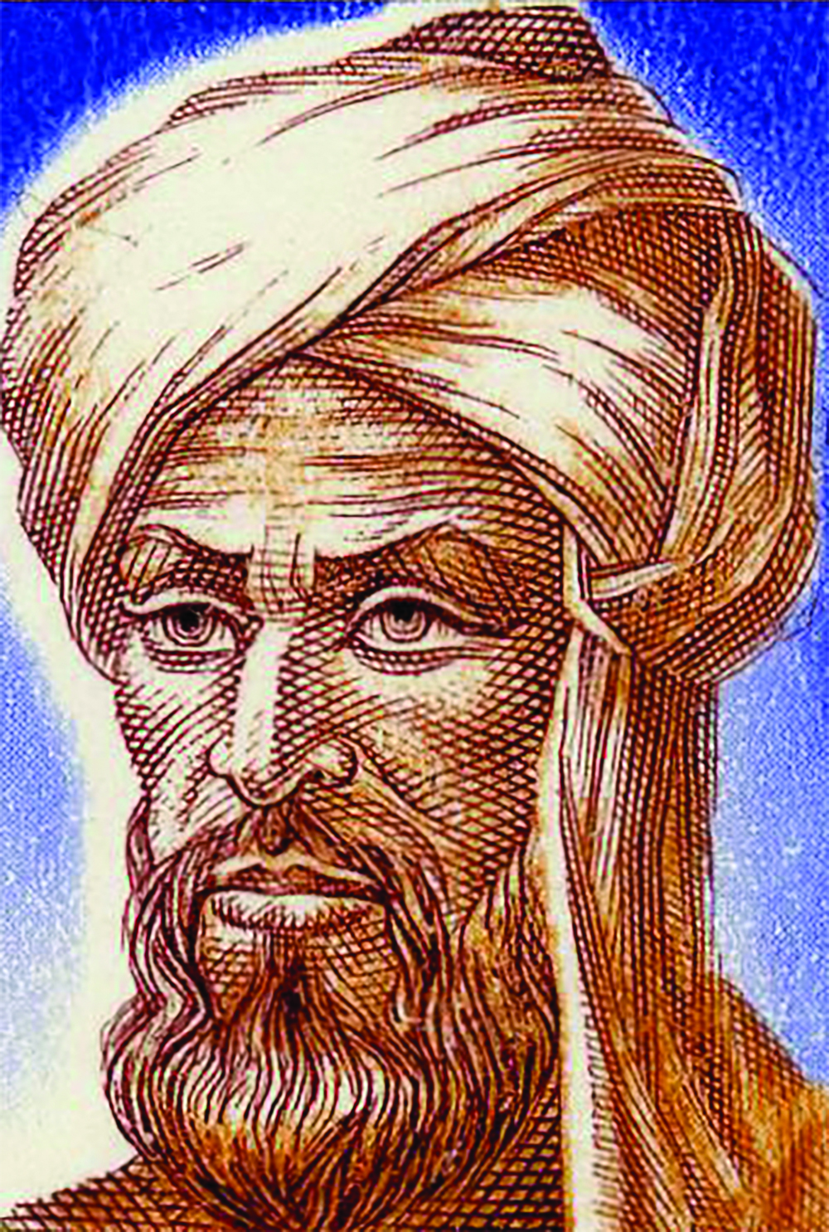
One of the pioneer directors of the Wisdom House in Baghdad in the early 9th century was Persian’s leading mathematician known as Muhammad Al-Khwarizmi. He supervised the translation of mathematical and astronomical masterpieces from the Greeks and Indians (including Brahmagupta) into Arabic language, and produced an original work that had a prolonged influence on the rise of Islam and (after his work spread to Europe through the Latin translation in the 12th century) later in European mathematics.

The word “algorithm” comes from his name translated into Latin, and the word “algebra” comes from “al-jabr” which is part of the name that he introduces in the basic method and problem solving techniques in algebra. This book is also translated into Latin.

His main contribution in the field of mathematics was his strong support of the Hindu numerical system, in which Al-Khwarizmi was recognized to have had a major influence in the revolution of mathematics in Islam and Europe. Figures 1 through 9 and 0 known as Hindu Arab numbers, was then adopted by the Islamic world. Later, with the translation of AlKhwarizmi’s work into Latin by Adelard of Bath and others in the 12th century, and with Fibonacci’s influence, it is widely used in Europe.

The most important contribution of Al-Khwarizmi is algebra, a word derived from the title of a mathematical text published around 830 BC called the “Al-Kitab almukhtasar fi hisab al-jabr wa’l-muqabala”. Al-Khwarizmi changed the way in which specific issues were solved by Indians and Chinese to a more general way of dealing with a problem. Subsequently, he created abstract mathematical languages that are being used throughout the world to date.

His book is recognized as the basic text of modern algebra, though he does not use the algebraic notation used now (he uses words to describe problems, and diagrams to solve problems). However, the book provides a complete guide to the completion of polynomial equations until the second level, and for the first time introduced the basic “algebra” method (rewriting an expression in a simpler form), “solution” (moving the negative quantities from one side of the equation to the other side and changing its symbol) and “balance” (subtraction of the same quantity on both sides of the equation and cancellation of the same coefficients on opposite sides).

In particular, Al-Khwarizmi developed a formula to solve systematic quadratic equations (equations involving unknown 2 or x² numbers) using “solutions” and “equilibrium” methods to reduce any similarity to one of the six forms, which can be solved. He describes the general equations in the form of “squared” (now known x²), “roots” (now known as “x”) and “numbers” (coefficients) and identifies six types of forms. They are: the square as the square root (ax² = bx), the square as equivalent of the number (ax² = c), square root as equivalent to the number (bx = c), the square and the square root is equivalent to the corresponding number (ax² + bx = c), the square and number as equivalent to the square root (ax² + c = bx) and square root and number as equivalent to the square (bx + c = ax²).

Besides mathematics, Al-Khwarizmi has also made an important contribution to the field of astronomy. Largely based on the method from India, he developed the first quadrant (an instrument used to determine time through observations of movements of the sun or star), which was the second most widely used astronomical instrument in medieval times after astrolabe. He also produced a revised version of Ptolemy, which deals with geographic research, which contains a list of 2402 coordinates of cities known around the world.

