Walking Through Time
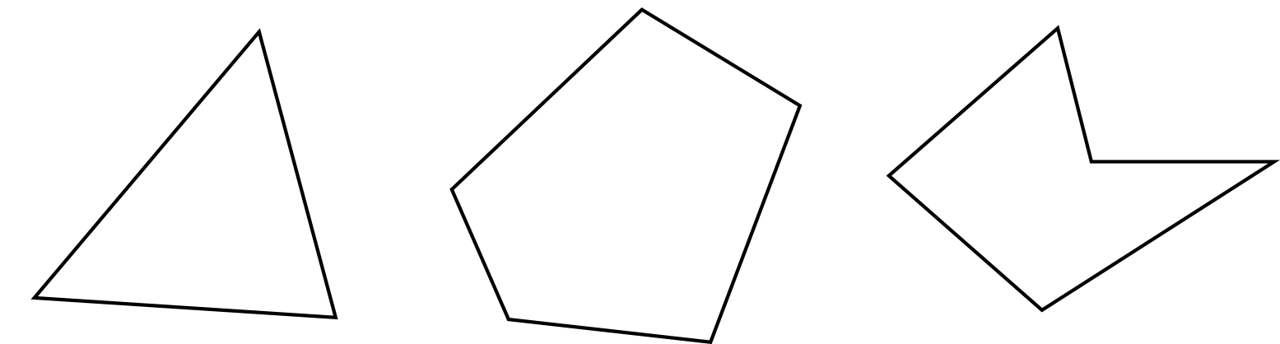
A polygon can be defined (as illustrated above) as a geometric object consisting of several points (called diagonal) joined with a straight line (called sides), in other words, the polygonal closed line is located on the plane “(Coxeter and Greitzer 1967, page 51).

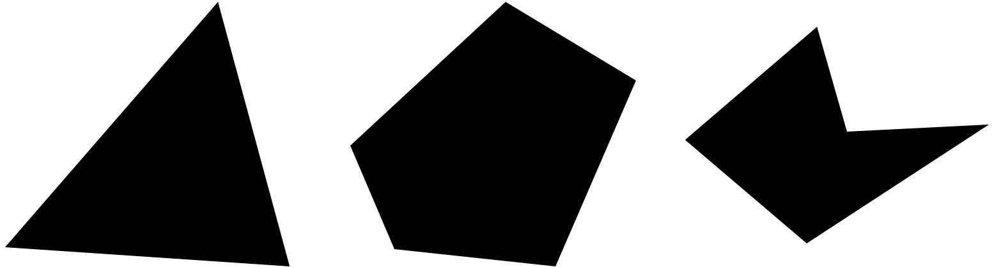

However, there is a big difference in the definition of polygon. Amongst others, some sources defined polygons as “closed planes with straight edges” (Gellert et al 1989, p. 162), “closed plane bounded by straight line segments as the sides” Bronshtein et al, 2003, p. 137), or “ a closed plane bound by three or more line segments closed in pairs in a same uniform number, and not intersecting other than the diagonal “(Borowski and Borwein 2005, Ms 573). This definition shows that polygons are a set of line segments coupled with the region they include, although they do not specify exactly what is meant by “closed plane” and as a whole depicts polygons as closed lines without curvatures inside.

The word “polygon” comes from the Greek word, poly meaning “many,” and gonia, which means “angle.”

The most common types of polygons are convex polygons with sides and angles in the same length. Polygon expanded into three dimensions is called polyhedron, into four dimensions called polychoron, and n dimension is called polytop.

