Walking Through Time
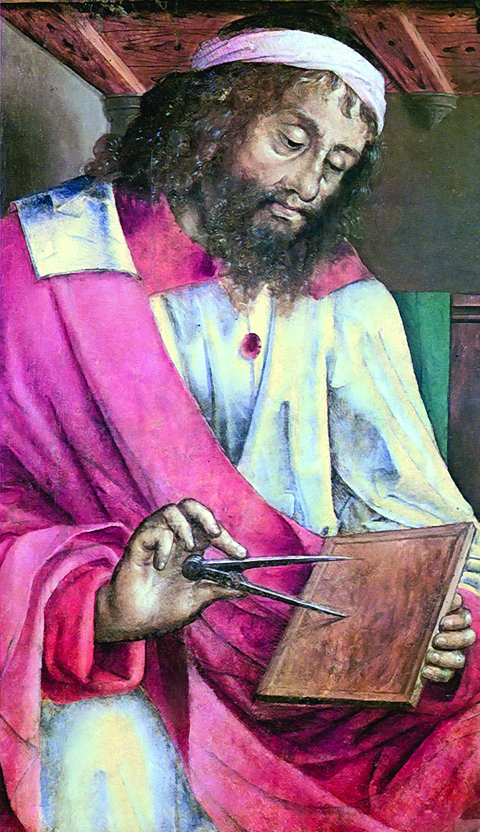
Euclid Alexandria is a prominent mathematician who is best known for his masterpiece in mathematics, Elements. The superiority of the work being the main reference in one of the mathematical branches over a long period of time makes Euclid to be recognized as the leading mathematics teacher of all time. However, little is known of Euclid’s life except of his life as a teacher in Alexandria, Egypt.

The acclaimed work of Euclid is “Elements”. The work is a compilation of knowledge that became the centre of teaching Mathematics for 2000 years. Perhaps there is no proof shown in the Elements by Euclid himself, but the order and disclosure of the contents of the work is produced by him. There is enough evidence to prove that Euclid used a previous textbook when he wrote Elements where he introduced some definitions that have never been used such as oblong, rhombus and rhomboid.

Elements begin with definition and five postulates. The first three postulates tell about construction in math. As an example, the first postulate states the possibility of constructing one straight line between two points. Postulates two and three relate the construction of straight lines and circles, and conclude the uniqueness of an object from a construction. The fourth postulate say all right angles are the same. The fifth postulate states about parallel lines. The knowledge from these postulates pioneered the study of geometry known as Euclidean geometry.

Elements is divided into 13 books. The first to the sixth book discusses the geometric plane. Books one and two discuss the basic properties of triangles, parallel, parallelograms, rectangles and squares. The third book discusses the properties of the circle while the fourth book deals with problems related to the circle. The fifth book discusses the topic of proportion.

The sixth book discusses the application from the findings in the fifth book on which the book is related to the geometric plane. The seventh to the ninth book discusses the number theory. The eighth book discusses the development of geometry. The tenth book discusses the theory of irrational numbers and is the result of the main Theaetetus study.

The eleventh to thirteenth book discusses the study of three-dimensional geometry. The eleventh book stipulates the basic definition required to discuss the contents of all three books. As a result, the twelfth book states that the circle is the combined diameter of a square and the sphere is the combined diameter of a cube block. The thirteenth book discusses the characteristics of five common polyhedral and proves that it is exactly five.

The extraordinary creation of Elements is where the theories are expressed and proven. The standards provided make Elements as the goal for calculus researchers over the centuries. Elements have been produced in thousands of editions since it was first printed in 1482.

Euclid may not be the ultimate mathematician, but his masterpiece, Elements used for a very long time, made him the leader of ancient mathematics or perhaps all-time mathematician.

Articles by: J J O’Connor and E F Robertson

