Walking Through Time
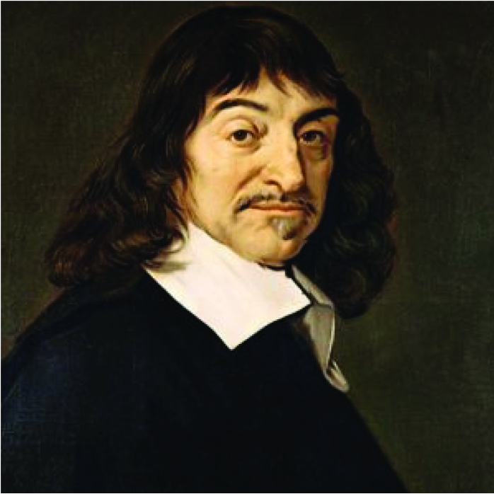
René Descartes (1596-1650)

René Descartes was dubbed “Father of Modern Philosophy”, but he was also one of the major figures in the 17th Century Science Revolution, and could be regarded as the first person to form modern mathematical schools.

It is in “La Géométrie” that Descartes was the first to suggest that every point in two dimensions can be described as two numbers on a plane. One of the numbers in the horizontal location and the other in the vertical location, also known as Cartes coordinates. He uses a vertical (or axial) line across a point called the origin, to measure horizontal (x) and vertical (y) locations, both positive and negative. It effectively divides the plane into four quarters. Any equation can be represented in a plane by plotting a set of solutions to the equation on it.
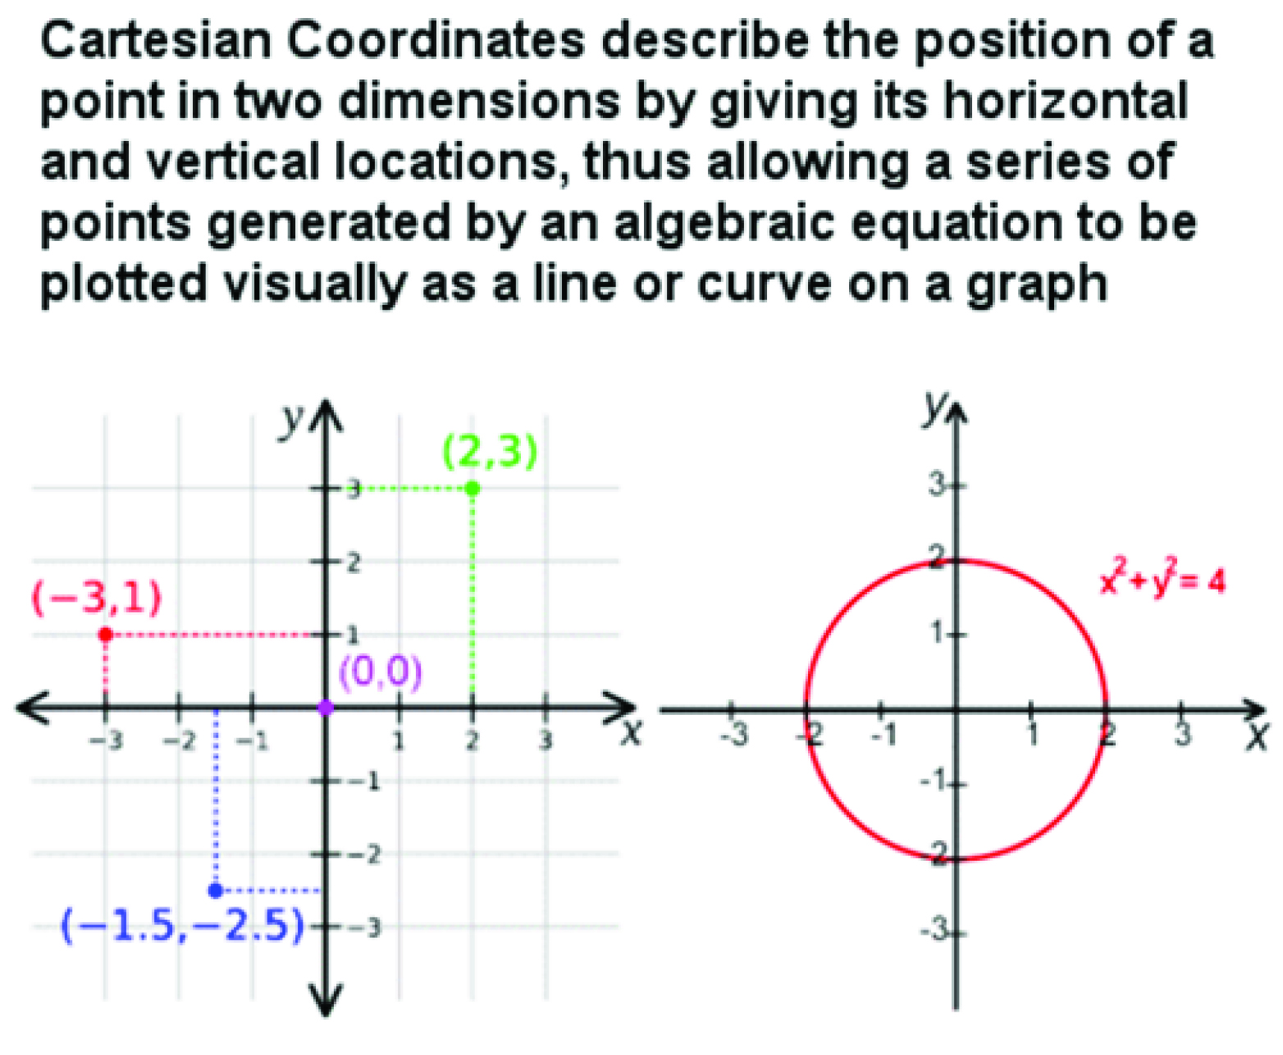

The latest idea and approach introduced by Descartes’ is analytic geometry or Cartesian geometry, having the effect of allowing algebraic geometric conversion (and vice versa). Therefore, a pair of simultaneous equations can now be solved either algebraically or graphically (at two intersections). The idea has sparked the discovery in calculus by Newton and Leibniz. It also provided an opportunity to geometry to a higher dimension, impossible to visualize physically - a concept that has become the centre of modern technology and physics - thus transforming mathematics forever.
In view of his services in the development of modern mathematics, Descartes today is best known as a philosopher who employs himself as a rationalist and being dualistic. His philosophy is the method of being dubiousness of everything, then rebuilding the knowledge directly from foundation, and he is known often quoting the statement (“I think, therefore I am”).

Until now, he was very influential in the development of modern physics. He contributed the first law of nature and the principle of conservation of the movement. The idea contributed greatly to the advancement in optics and the study of reflection and refraction of light and the most popular theory was the movement of the late 17th century planet.

The ideas of the revolution made him the centre of controversy in his days, and he died in 1650 away from home in Stockholm, Sweden. 13 years later, his work was placed in the Catholic Church listed in the “Forbidden Books Index”.

